**Lab Environment**

* While creating the Hyper-V Host use the restart’s from Hyper-V and one restart will take a long time (20 mins) for updates
* Next Step: Lets ensure password based authentication is up the virtual machines created by hyper-v host
* login into the VM
* edit the /etc/ssh/sshd_config file to replace PasswordAuthentication to yes from no
* restart sshd service sudo service sshd restart

**AWS Server Migration Service**

* AWS Server Migration Migration Server can be used to migrate vms from Hyper-V or vmware to AWS
* Navigate to Server Migration Service  
  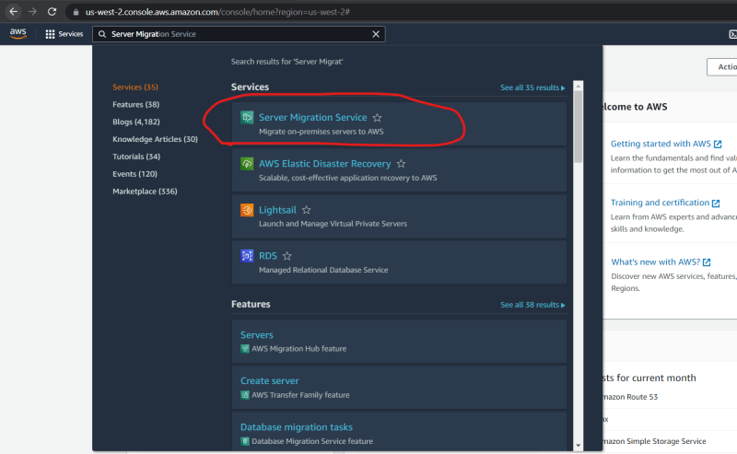  
  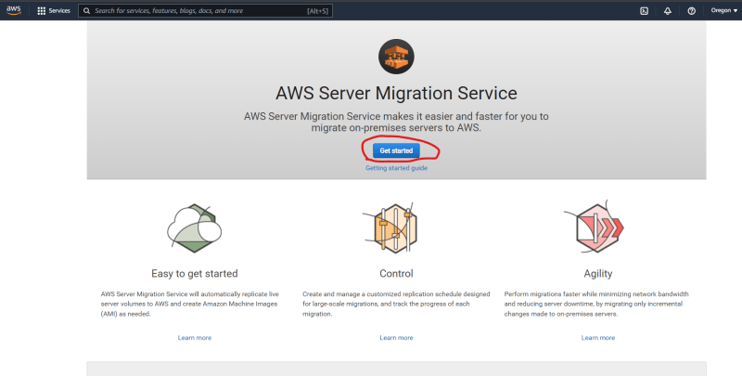
* Download connecter into hyper v host  
  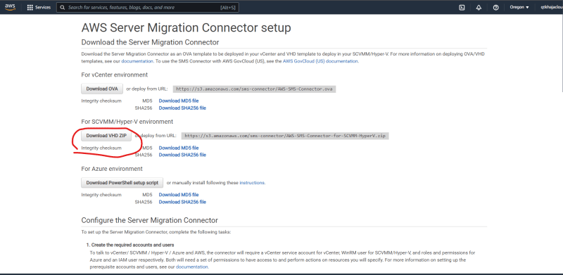
* Ensure the requirements are met [Refer Here](https://docs.aws.amazon.com/server-migration-service/latest/userguide/prereqs.html)
* Once the download is finished install the connector by following docs [Refer Here](https://docs.aws.amazon.com/server-migration-service/latest/userguide/HyperV.html)
* Unzip the downloaded file and import the vm as shown in the class to create a connector and after starting the vm execute the following steps [Refer Here](https://docs.aws.amazon.com/server-migration-service/latest/userguide/HyperV.html#download-hyperv-connector)
* Now Access the connector  
  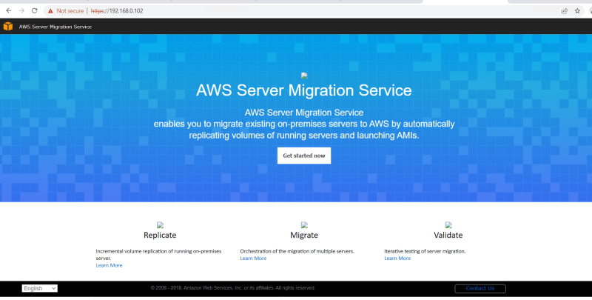
* Now follow the wizard, enter access and secret key as shown in the class
* Now lets establish connectivity  
  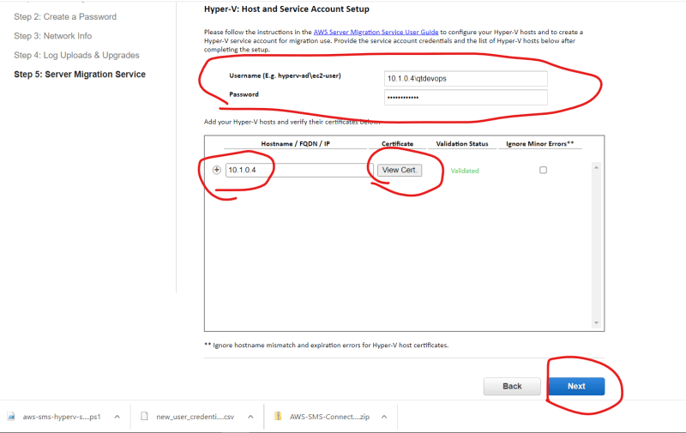
* Now after succesful connection you will be navigate to connector dashboard  
  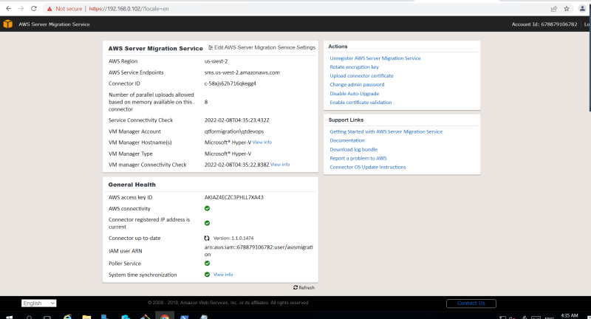
* Now navigate to AWS Console -> Server Migration Service and View Connectors  
  